The Call of the Wild VIDEO GAME
MOOD: Afraid / triumphant
Level 7 -- The Sounding of the Call

Part 1
The Journey
The level opens with Buck traveling with John Thornton, Hans and Pete to the fabled gold mine.
You, as Buck, must leap over crevices and hop across wild mountain streams.
At streams, Buck can catch fish, which will give him extra energy.

Part 2
Follow the Caveman
Here, we enter Buck’s campfire vision. You must follow the hairy man and protect him from any predators. Beware of bears, wolves, stampeding elephants and dive-bombing eagles!

Part 3
Befriend the Wolf (mini-level)
Buck must befriend the wild wolf brother. Keep up with wolf brother throughout the forest to earn his trust!

Part 4
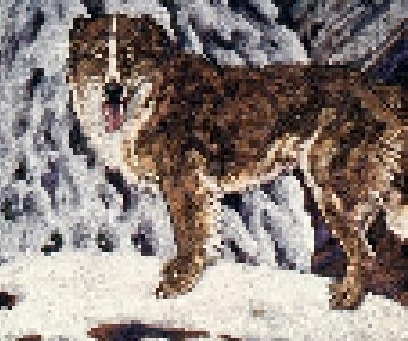
The Hunger Game
Buck must track down the old Bull Moose and defeat him. Attack combos will allow you to separate the Bull Moose from the rest of the pack. Use your defense button to prevent the moose from eating food and drinking water, then use the attack button again to take down the moose when his energy reaches 50%.

Part 5
Yeehat Revenge
Buck has sensed a terrible turn of events. Defeat the Yeehats with “Ghost Dog” attack mode and evade the Yeehat spears and arrows. Exact revenge for your master John Thornton.
Victory will enable you to hear...

Part 6
The Call of the Wild (video ending)
Buck intimidates and befriends the entire wolf pack. In the final scene, Buck mournfully howls by the pool of water and then runs down into the moonlit valley, appearing at the head of the galloping pack.

